1.Car Dealerships need to keep records of every vehicle they have in stock along with what has been sold, yet to be sold, and cannot be sold. Consumers and salesmen need information on the vehicle being sold, i.e., make, model, manufacture date, gas mileage, etc. The business needs to actively keep track of what cars are in stock, what upgrades or features are available, what colors, etc. They might also want to keep track of what is selling, such as what color is most popular, or if people commonly add heated seat options.

In order to improve the dealerships efficiency in selling its products, a system should be built. In this system, every item, whether it be a vehicle or accessory, will be tagged with valuable information in order for its user to easily find the item they are looking for. For example, Make & Model, Body Type, Year & Mileage (if applicable), Fuel Type (Gas, Hybrid, Electric, etc.), Color (Interior and Exterior), Seating Capacity, Drivetrain, Transmission Type, and Cylinder amount. Every item will have multiple images depicting what exactly the item is. Tagging every item would complement a filtering system that would allow the user to select the tags they are interested in and filter out the vehicles that do not meet the search specifications. The user will also be able to sort, ascending or descending, through the inventory list by Availability, Manufacture Date, Alphabetically, Price, and Mileage. This information will be added, updated, and, if necessary, archived by a dealership salesman or executive. The salesman will also have the ability to add discounts and/or special promotions to certain items.

In contrast to a pen and paper system, a fully electronic system will allow for car salesmen and other employees to quickly update data regarding the state of their products. If a car is being sold, the information that the car is being sold will be sent almost instantaneously to whatever parties need to be involved for the transaction to be placed, whether it be the banks or the warehouses. In addition to worker efficiency, it helps the customer determine what they would want to buy before they come into the dealership. They'll be able to see what products are available to view online and can even side-step visiting the dealership by buying the product online.

2. Customers, management, agent(salesman), Admin system operator.

3. Manage cars, manage car models, manage sales, manage inventory, manage customers, manage users, View cars, request quotations, make payments, adding cars, create quotations, view requests, create invoice, .

| Use Case | Actors |
| --- | --- |
| Manage cars | Admin, Managers |
| Manage car models | Admin, Managers |
| Manage sales | Admin, Managers |
| Manage inventory | Admin, Managers |
| Manage customers | Admin, Managers |
| Manage users | Admin |
| View cars | Customer, Salesman |
| Request quotations | Customer |
| Make payments | Customer |
| Adding cars | Salesman |
| Create quotations | Salesman |
| View requests | Salesman |
| Create invoice | Salesman |
| Request invoice | Customer |

4.

* **Manage cars:** Both Managers and Admins oversee and control the overall inventory of vehicles at the dealership. It includes tasks such as tracking the number of cars in stock, managing the distribution of vehicles to various salespeople or locations within the dealership, and ensuring that the inventory is up to date and reflects the current availability of cars.
* **Manage car models:** Both Managers and Admins manage different car models in the dealership’s inventory. They are able to decide which car models to stock, set pricing strategies for different models, and monitor the performance of each model in terms of sales and customer interest.
* **Manage sales:** This involves Managers and Admins overseeing and optimizing the sales process within the dealership. It encompasses tasks such as setting sales targets and goals, monitoring the performance of sales staff, analyzing sales data, and implementing strategies to increase sales and revenue.
* **Manage inventory:** This entails managers focusing on the logistics and availability of vehicles at the dealership. Managers and Admins in this use case are responsible for tasks such as tracking inventory levels, making decisions about restocking or reducing inventory, and ensuring that the inventory is well-maintained.
* **Manage customers:** This involves Managers and Admins overseeing customer relationship management activities within the dealership. This includes tasks such as maintaining a customer database, tracking customer interactions, and developing strategies to attract and retain customers.
* **Manage users:** The Admin manages users in the online system of the dealership and takes care of their information in the system. The Admin keeps track of information such as what the user is in the market for, what car they already drive, their budget for a new car, and what cars they have purchased already.
* **View cars:** This use case allows the salesperson and the user to view the inventory of cars and take a closer look at a specific car model.
* **Request quotations:** This use case allows the user to request a quotation from the salesperson on how much a specific car costs.
* **Make payments:** The user makes payments towards a vehicle to the dealership
* **Adding cars:** The salesperson adds vehicles to the existing inventory of the dealership
* **Create quotations:** This use case allows the salesperson to receive quotation requests from the user and return a quote to them with the cost of a particular car.
* **View requests:** This allows the salesperson to view all user requests for the particular vehicles they are interested in this
* **Create invoice:** Per request by the user, the salesperson can create an invoice for the user when they purchase a car
* **Request invoice:** The user may ask for an invoice from the salesperson after purchasing a car

5.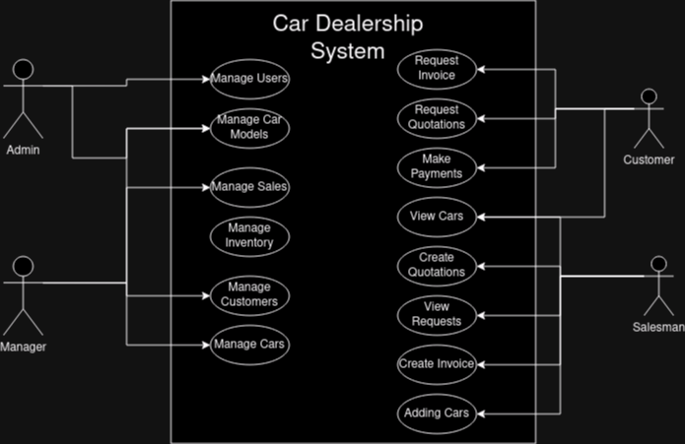

Considering your group project system, work collaboratively and think carefully to answer following questions.

1. Create your system vision document (problem description, system capabilities and business benefits). *(Maximum length : 1 page , single-spaced)* 10 Pts. (Jeff Song)
2. Identify and list all stakeholders of your system. 5 Pts.tak
3. To what events must your system respond? List each event, the resulting use case and the actor(s). 10 Pts.tak
4. Write a brief use case description for each use case. (Kareem Elaasar) 15 Pts.
5. Draw a use case diagram for your system. 10 Pts (Carlos)  
   (general brainstorming. Mark G)